**Spark Jobs:**

1). This Program aims to calculates the average review count for businesses in each category and then displays the top 10 categories with the highest average review counts.

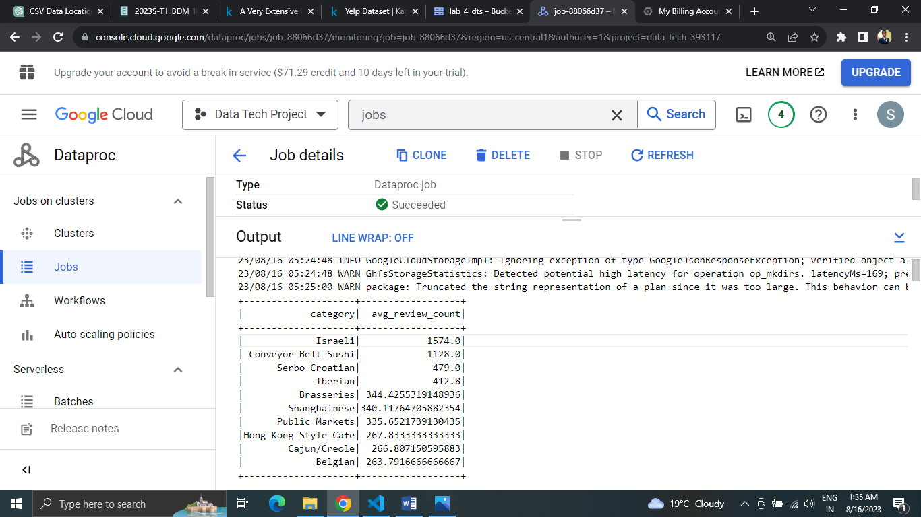

From the output of the PySpark job that analyzed the business categories and their average review counts, we can infer the following:

1. **Popular Categories:** The top categories with the highest average review counts are likely to be the most popular or well received by customers. These categories are getting more attention and positive reviews from customers.
2. **Customer Satisfaction:** Categories with higher average review counts suggest that businesses in those categories are providing good products or services that customers are satisfied with. It reflects positively on the quality and customer experience.
3. **Demand and Engagement:** Categories with higher average review counts might indicate higher demand and engagement from customers. Businesses in these categories might be attracting more customers and generating more reviews.
4. **Potential Business Focus:** Businesses looking to succeed could consider entering or expanding into categories that have higher average review counts. It could be an indicator of potential success in terms of customer satisfaction and engagement.
5. **Areas of Improvement:** On the flip side, categories with lower average review counts might indicate areas where businesses could improve. Lower review counts might suggest less customer engagement or potential areas for enhancement.
6. **Market Trends:** Analyzing popular categories can provide insights into current market trends and consumer preferences. Businesses can adapt their strategies to align with these trends.

2). This Program aims to calculate the average review count for businesses in each state, along with the highest average review count state-wise. It then shows the top 5 states with the highest average review counts.

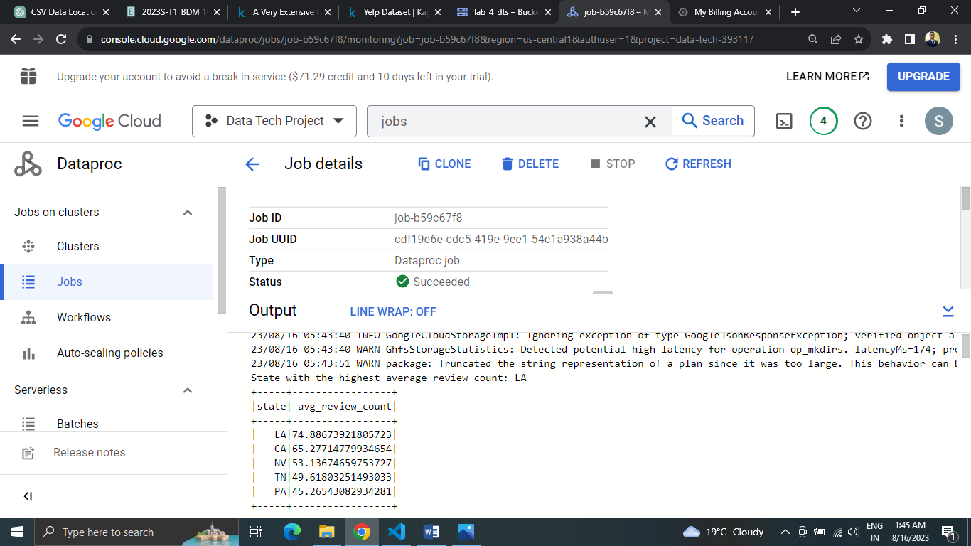

From the output of the PySpark job that analyzes the average review counts for businesses in different states, we can infer the following:

1. State with the Highest Average Review Count: The code identifies the state with the highest average review count among businesses. This state is likely to have businesses that are popular and receive a higher number of reviews on average.
2. Customer Engagement and Satisfaction: States with higher average review counts suggest that businesses in those states are able to engage customers effectively and provide satisfactory products or services.
3. Positive Consumer Perception: States with high average review counts could indicate that businesses in those areas are well regarded by their customers, leading to positive word-of-mouth and higher engagement.
4. Business Opportunities: Entrepreneurs or investors might consider exploring business opportunities in the states with high average review counts. These states could have a favorable environment for businesses to thrive.
5. Regional Preferences: The analysis offers insights into regional preferences for certain types of businesses. Higher average review counts might suggest that customers in those states are more active in reviewing and engaging with businesses.

3.) This Program aims to find the Top 5 Business with most number of 5 Star rating with the total review.

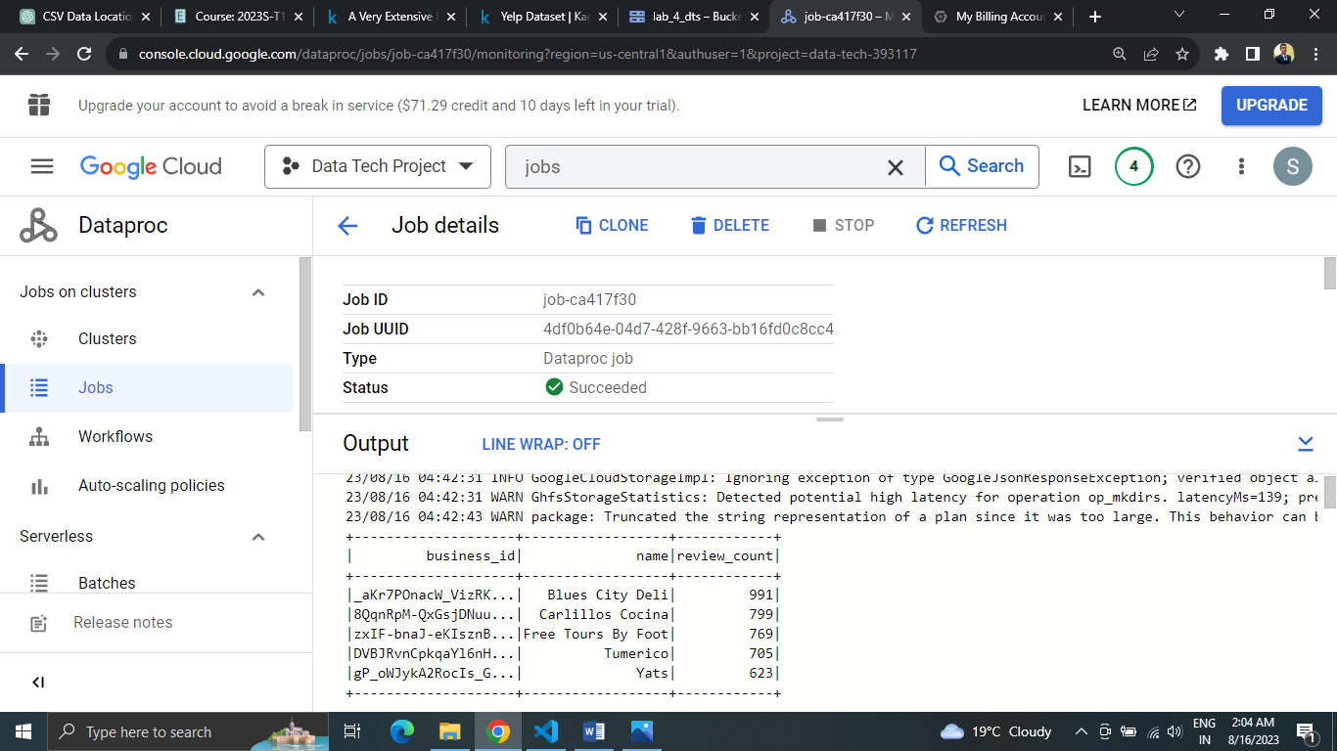

From the output of the PySpark job, we can infer the following:

1. Quality and Popularity: The displayed restaurants have received 5-star ratings and boast a high number of reviews. This indicates both exceptional quality and strong popularity among customers.
2. Customer Satisfaction: The combination of high ratings and numerous reviews suggests that these restaurants consistently deliver positive experiences, making customers more likely to share their satisfaction.
3. Engagement Matters: The higher review counts among these top-rated restaurants highlight active customer engagement, demonstrating that they not only attract customers but also encourage them to leave reviews.
4. Customer-Centric Approach: The success of these restaurants is rooted in prioritizing customer preferences and needs, leading to both high ratings and a substantial customer base.
5. Market Leadership: These top-rated restaurants stand out in the competitive market due to their quality and customer engagement, making them potential market leaders that others in the industry can look up to.